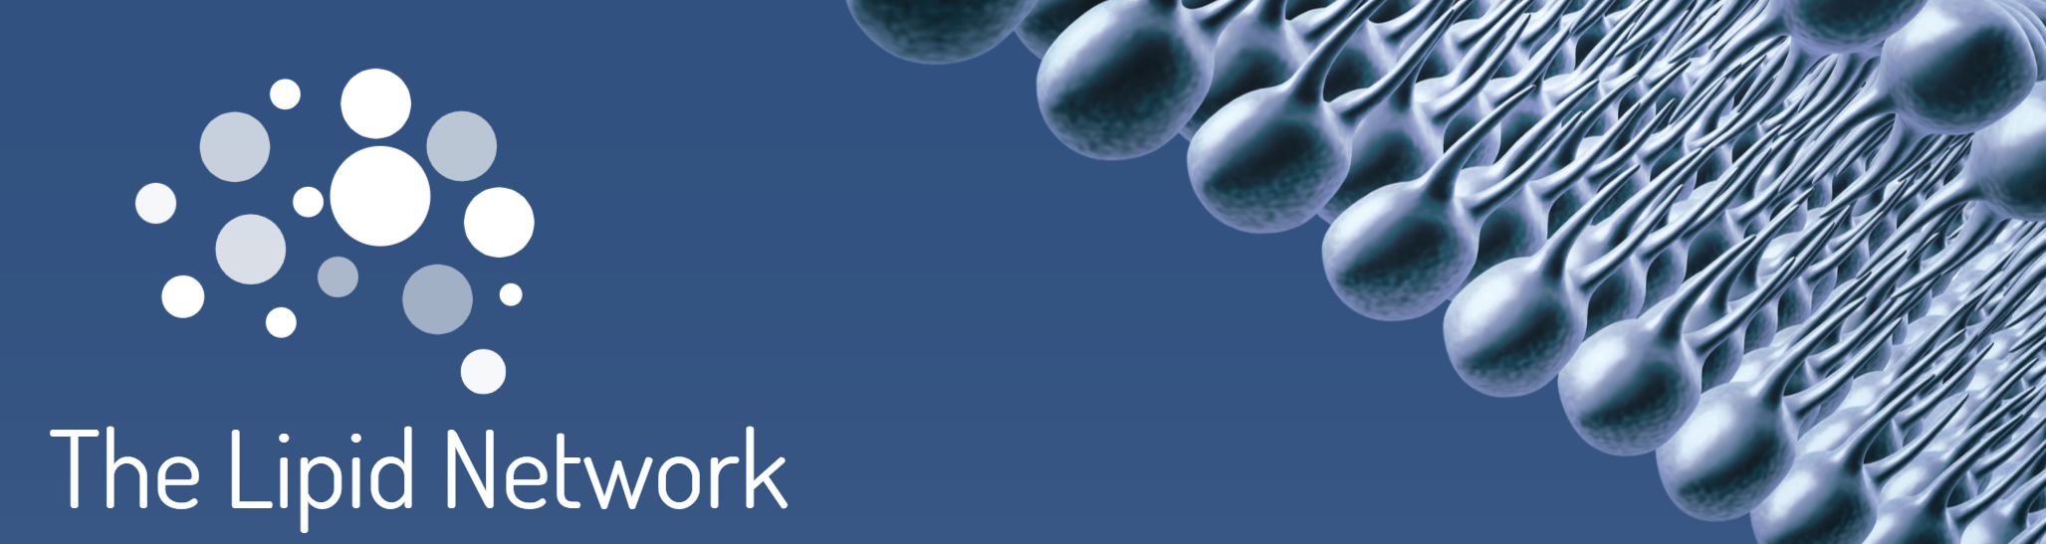

THE LIPID NETWORK
2026 COLLABORATION AWARD
Sponsored by the National Deuteration Facility (ANSTO)
SUBMISSION FORM

Purpose
The Lipid Network Collaboration Award recognises outstanding published collaborative research that advances the understanding of lipids and lipid-related science. The award celebrates productive collaborations within the lipid research community and encourages multidisciplinary partnerships that strengthen lipid research outcomes.

Award Value
USD $500 awarded to the submitting author.

Applicant Details
Submitting Author: ……………………………………………………………………………………………………….
Institution: ……………………………………………………………………………………………………………………….
Country: ………………………………………………………………………………………………………………………..…
Email: …………………………………………………………………………………………………………………………….….
Year PhD Awarded: ………………………………………………………………………………………………………

Publication Details
Article Title: ……………………………………………………………………………………………………………………
Journal: …………………………………………………………………………………………………………………………..
Date of Acceptance: …………………………………………………………………………………………………….
Date of Publication (if applicable): …………………………………………………………………………..
DOI: ………………………………………………………………………………………………………………………………….

Eligibility Checklist
☐ Applicant is an EMCR (within 15 years of PhD award).
☐ Publication was accepted within the previous 18 months.
☐ All co-authors have a profile on The Lipid Network.
☐ Applicant is a co-author of the nominated publication.

Collaboration Statement (Maximum 150 Words)
Describe: (1) Nature and scope of the collaboration; (2) Contributions of collaborating researchers and institutions; (3) How the collaboration strengthened research outcomes; (4) Relevance to lipids and lipid science.
Collaboration Statement (150 words):

Research Impact Statement (Maximum 150 Words)
Describe the real-world impact of the research arising from this publication. This may include actual or potential benefits to human health, healthcare delivery, public health, economic outcomes, industry innovation, environmental sustainability, policy development, or community wellbeing. Applicants should explain how the findings have contributed, or are likely to contribute, beyond academic knowledge to generate meaningful societal, clinical, economic, or environmental benefit.
Research Impact Statement (150 words):

Assessment Information
Most relevant SCImago subject category:
Were deuterated or labelled materials used in this study? ☐ Yes ☐ No
If yes, briefly describe their use (150 words max):

Required Attachments
☐ PDF copy of the published article
☐ Evidence of publication date (acceptance email or publication confirmation)

Conditions
- Each submitting author may submit only one article for consideration in a given award round.
- Only one submission may be made per publication.
- Incomplete applications may not be considered.
- The judging panel reserves the right not to award the prize if suitable applications are not received.
- The panel's decision is final.

Declaration
I confirm that the information provided is accurate and that this submission meets the award eligibility requirements.
Signature: ____________________ Date: ____________

Submit by this completed form and required attachments via email: admin@thelipidnetwork.com

Assessment Criteria
Applications will be scored out of a maximum of 16 points.

1. Collaboration Score (up to 5 points)
The judging panel will assess the comprehensiveness and significance of the collaboration, including diversity of expertise, contributions from multiple institutions or disciplines, and evidence that the collaboration strengthened the research outcomes.

2. Research Impact Statement (up to 5 points)

Describe the real-world impact of the research arising from this publication. This may include actual or potential benefits to human health, healthcare delivery, public health, economic outcomes, industry innovation, environmental sustainability, policy development, or community wellbeing. Applicants should explain how the findings have contributed, or are likely to contribute, beyond academic knowledge to generate meaningful societal, clinical, economic, or environmental benefit.

3. Journal Quality Score (up to 5 points)
SCImago Category | Points
Q2 journal | 1 point
Q1 journal | 3 points
Top 10% journal | 5 points
The submitting author is responsible for identifying the relevant SCImago category and providing supporting information if requested.

4. Use of Deuterated or Labelled Materials (1 points)
Well-defined research on deuterated and other labeled molecules will receive up to 1 additional point. Molecular labelling could include examples such as 13C, 15N or other stable isotopes.

Selection Process
Applications will be reviewed by a judging panel appointed by The Lipid Network. Scores from all assessment categories will be combined to determine the award recipient. In the event of a tie, the judging panel may consider the overall significance of the collaboration and its contribution to lipid research. Late submissions will not be considered.

